**Questions:**

**COUNTIF/COUNTIFS**

1. How many orders were shipped via second class in the year 2013?

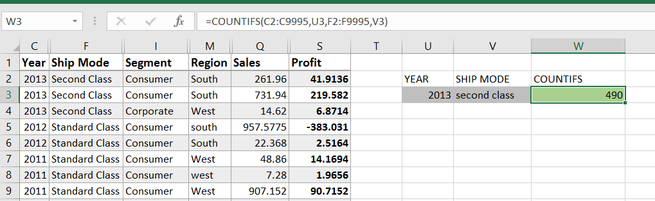

1. How many orders were shipped to the western region via Standard class in the year 2012?

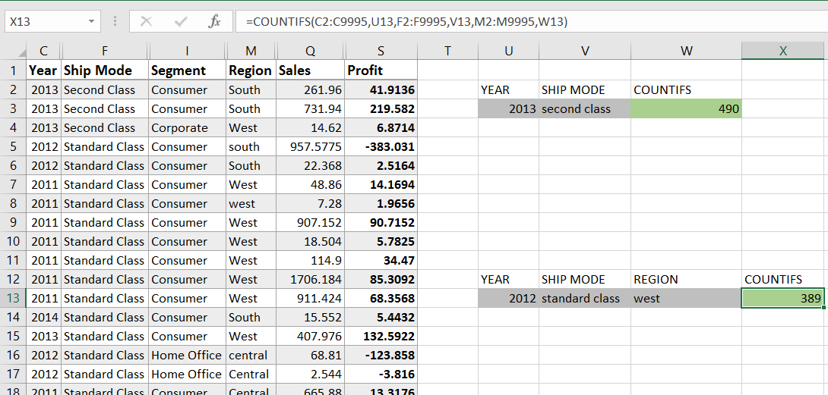

**SUM/SUMIFS**

1. What is the total sales amount for the southern region in the year 2014?

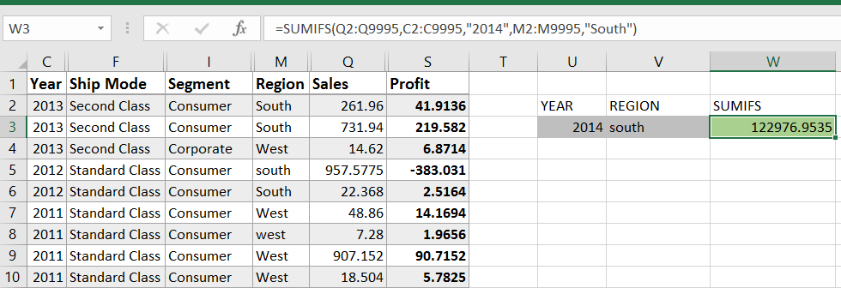

1. What is the total profit for the consumer segment in the year 2013?

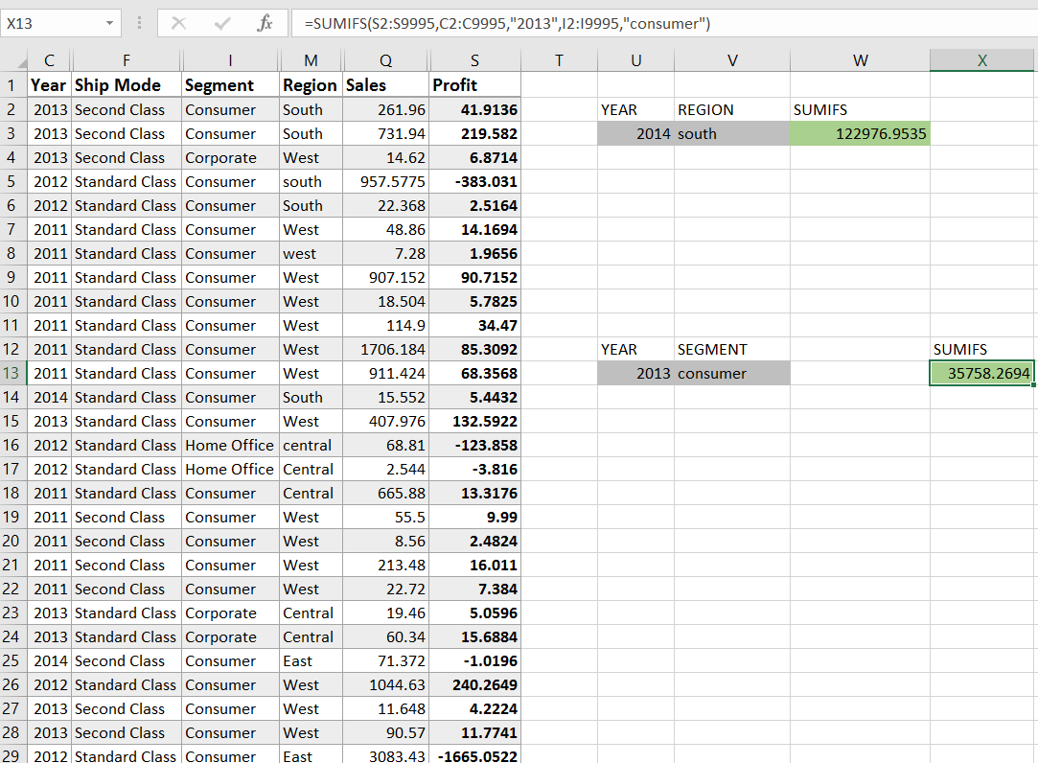

**AVERAGEIF**

1. What is the average profit for orders in the consumer segment?

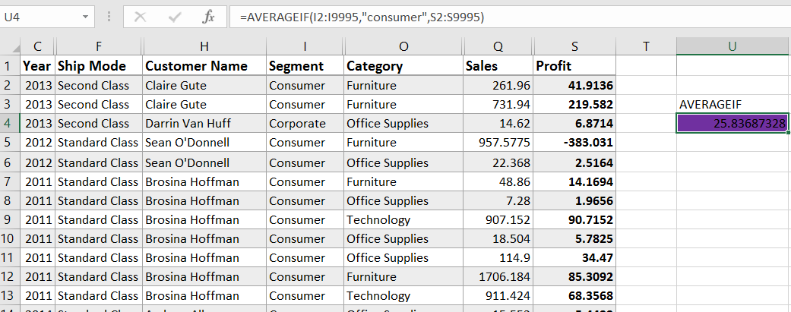

1. What is the average sales value for orders shipped via second class?

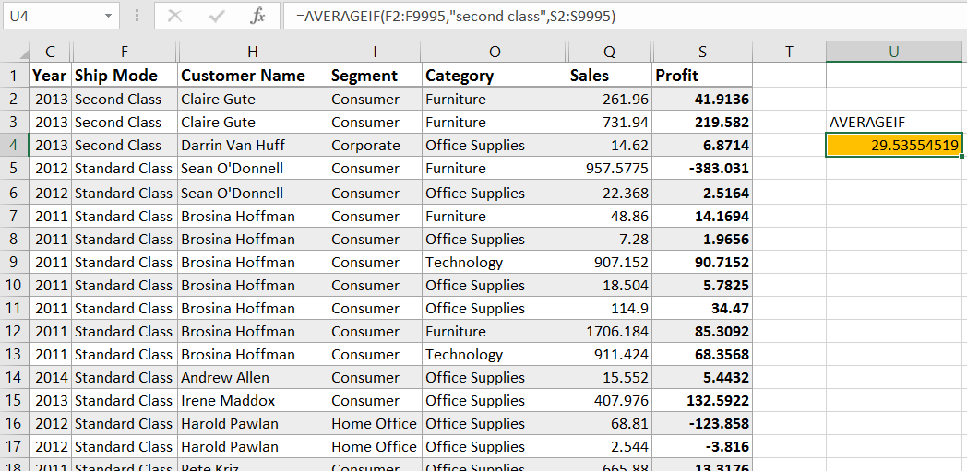

**SMALL/LARGE Functions**

1. What are the top 3 highest sales values in the dataset?

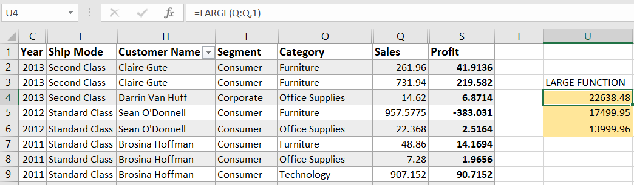

1. What is the bottom 3 lowest profit values in the dataset?

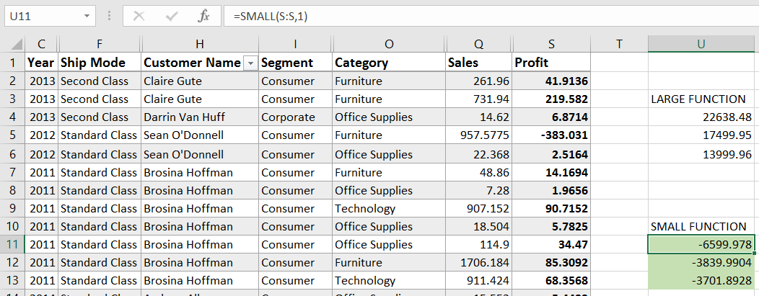

**MODE, MEDIAN, PERCENTILE**

1. What is the median sales value for the furniture category?

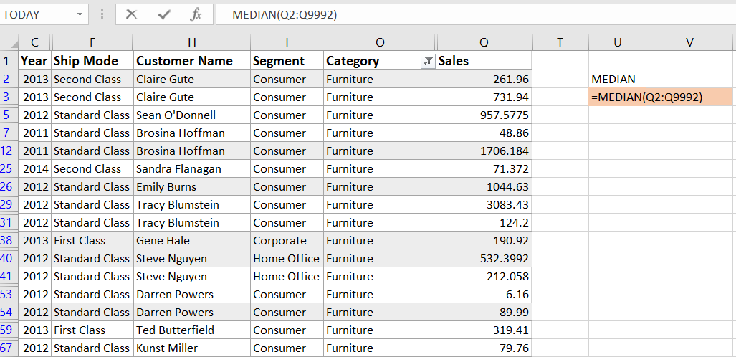

1. What is the 75th percentile of profit values for the corporate segment?

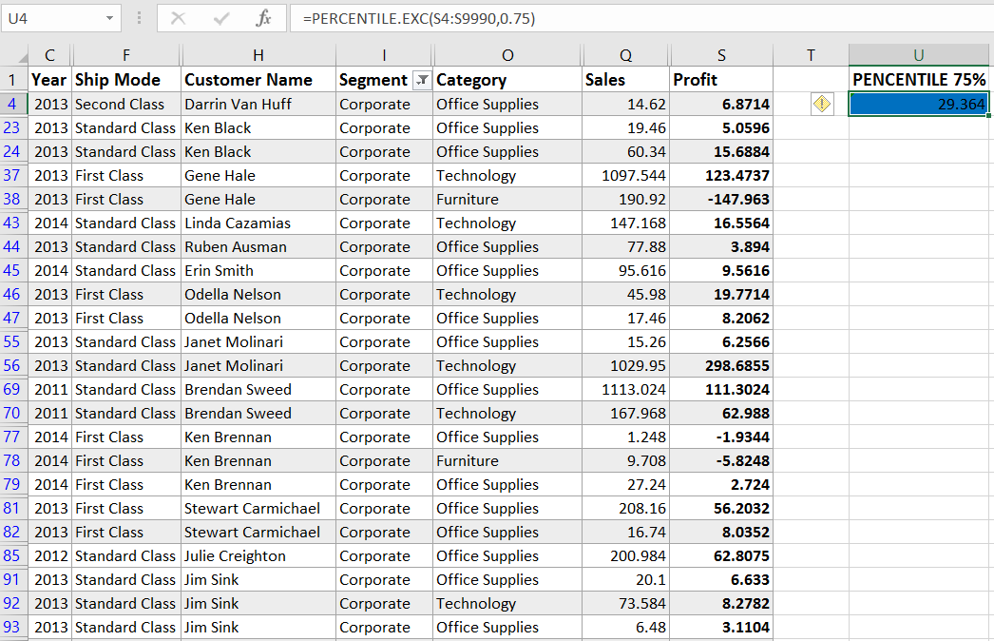

**RANK Function**

1. What is the ranking of each order based on its sales value?

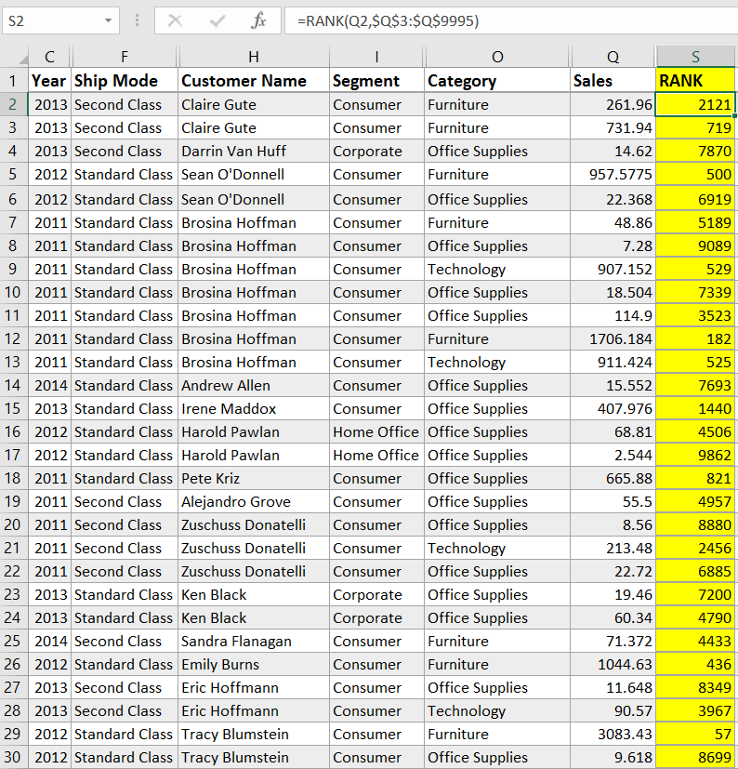

1. What is the ranking of each customer based on their total sales?

**TRIM Function**

1. How can you remove extra spaces from a name column?

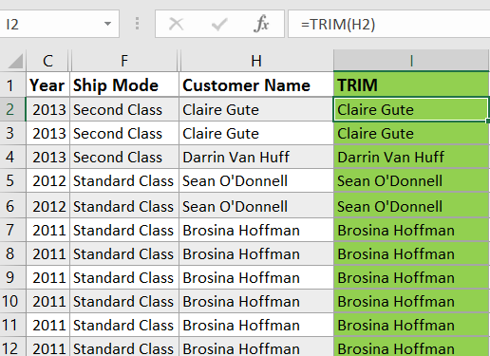

1. How can you remove leading and trailing spaces from a column?

Here's how to use it:

* Select the column containing the data with leading and trailing spaces.
* In an empty cell (preferably next to your data), type the formula =TRIM(A1) (assuming your data starts in cell A1).
* You can replace A1 with the actual cell reference of your first data point

Press Enter.

**UPPER, LOWER and PROPER functions**

1. How can you standardize the region column to uppercase?

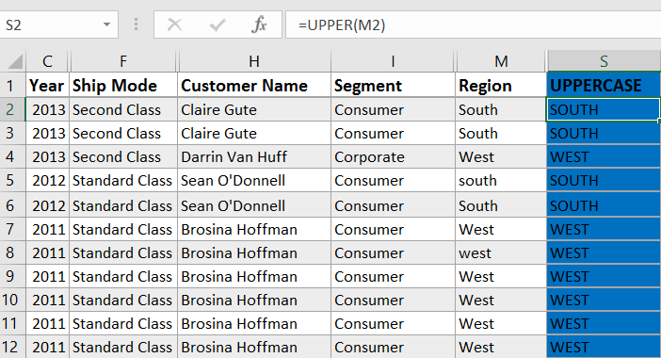

**CONCATENATE Function**

1. Combine the city and state columns into a single column.

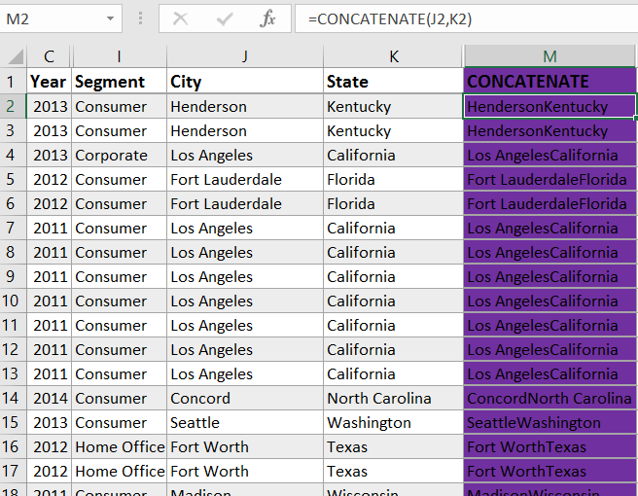

1. Combine category and subcategory columns into a single column

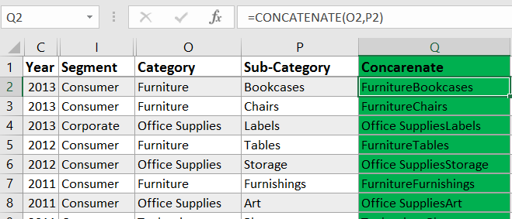

**LEFT, RIGHT, MID Functions**

1. How can you extract the first three characters of the order id?

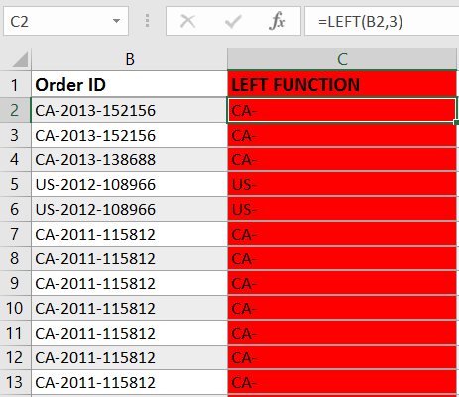

1. Extract the last two characters of the state column?

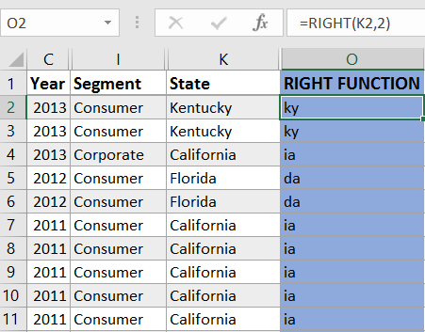

**LEN and FIND functions**

1. Count the number of characters in the customer name column

